# Changes Metadata

* ADP (Ads Platform)
* Code
* CR_EP (Experiment from ServiceNow)
* DSS
* MFE (Merch Front End)
* PlannedEP

[Sprint Demo 3/20/2023: ADP and PlannedEP Changes in Control Center](https://docs.google.com/presentation/d/1YxrjLiQSAWuhivxuW2NCUr4FYDXtGk7b/edit#slide=id.p1)

<https://lucid.app/lucidchart/a9fe1ded-14db-4b9a-901c-8464fed30fdb/edit?viewport_loc=-306%2C0%2C2219%2C1140%2C0_0&invitationId=inv_efe1cc48-cda0-4813-9a8a-2bbd5a54e006>

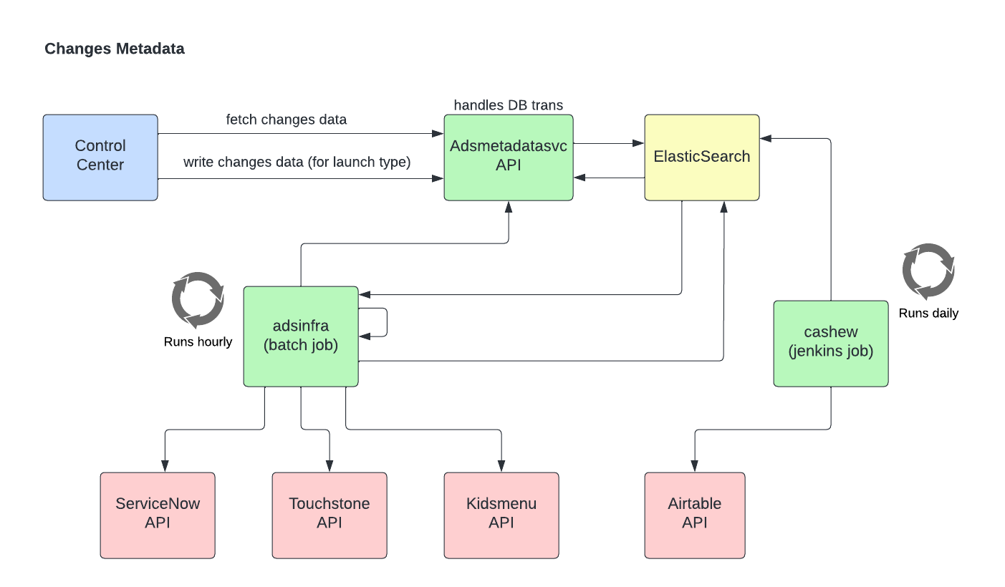

Index

Need to create new mappings for new index created every year.

PUT change_info_v2_metadata_2023/_mappings

{

  "properties": {

    "startAt": {

      "type": "date"

    },

    "endAt": {

      "type": "date"

    },

    "effectStart": {

      "type": "date"

    },

    "lastModifiedAt": {

      "type": "date"

    }

  }

}